This extension is as free as all open source software, but it's content, the graphic design, is only free for personal use.
Smileyman29-US 1.0 Jochen Gros Design and OxygenOffice Professional Team

“Smileyman” provides around 400 Emoticons, but they are different: Good old Smiley has got hands and feet to show body-language and even sex, so to say as Smileyman and Smileywoman. After installing, you may type for instance “happy”, “woman” or “striptease” and pop-up windows instantly offer equivalent icons – just press the return-key.

Examples for what you type and what you get, 29 or 58 pixel high:

couple couple 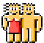 happy happy  office office 

greetings  greetings greetingsFemale 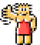 greetingsFemale

respectfully  sincerely  sincerely regards  cheers 

eat drink woman  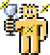 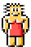 party  pizza 

beer 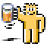 pub 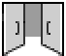 (for hangover type perhaps) beer puke 

smoke  smoke not  nonsmoker  smokedope ban 

no-icon  yes  yeah 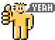

smoke good  best  super  great dance  

bad  shit  bad book  bullshit 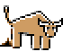 devil 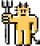

angel 
devil speak 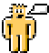 lying (kill) devil shoot 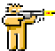
(shoplifting ) devil buy  (sin) devil sex 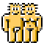 hell

mobile 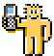 mobileFemale 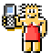 call  photo 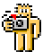 movie 

internet  email  cool computer  spam 

flower happy birthday 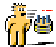 flowerFemale  good luck 

boxing 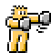 buddies  fight 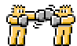 victory team  

art  gym  gymFemale 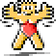 (architecture) art palace art 

going  welcome  travel 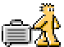 (hotel) travel public

backpacker  (pilgrim) backpacker jesus 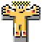 trekking

(bank) money money palace (castle) king queen palace 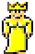

(court) justice palace 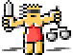 (library) book book palace

punish-metaphor 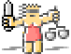 test-metaphor 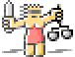

school  teacher  (university) PhD school 

think  thinkF 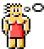 theory book  worry not 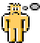

have  know  big knowledge   dream 

love  loveFemale 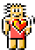 (pet) care dog  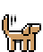 care careFemale 

(pet) care woman careFemale manMale  care womanNaked 

loveGreetings loveGreetingsFemale honest  sincerely

girlfriend 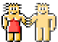 boyfriend 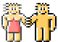 lovekissFemale 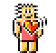 lovekiss 

anger angerFemale  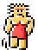 hate  hateFemale 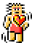

ecologist  ecocare  ecocare food  eco eat

Eroticons seduce 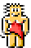 striptease 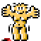 manNaked  womanNaked

singleFemale 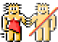 singleMale 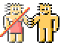

sex gay 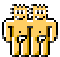 lesbian  (saver sex) save sex 

(sleep together) sleep with sleep  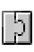

makelove 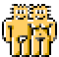 makeloveMale  makeloveFemale 

desireFremale you   desireMale womanNaked 

sex revolution 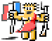 sex freedom 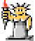

frustration 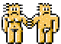 frustMale  frustFemale 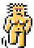

Icon-Pidgin: I-icon want food  

I'm cry   You're sick   we're happy 

we-icon like drive NewYork    

Napoleon meet the king 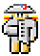 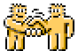 

no-icon give me-icon bullshit 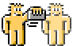

ILY-acronym  Iloveyou-movie 

Readme  read  me-icon

As “icon-typing” does not start until the third letter, words with only one or two letters are displayed in the pop-up window only while adding “-icon” such as “I-icon”, “we-icon” and so on.

Typing small or capital letters doesn't matter.

Install Smileyman extensions: open the menu “Tools > Extension Manager”

After installing make sure that the checkbox “Display remainder...” in the menu “Edit > Autotext” is enabled.

Animations may slow down, depending on your PC

Disabling Smileman extensions: open the menu “Tools > Extension Manager”
(It works only after restartin OpenOffice).

Smileyman58 will be provided in a different extension.

More about the whole project: www.icon-font.com
(Also with “Smileyman25”, three pixel lower, to fit into the MSN Messenger)

